- Award Information
The Duke of Edinburgh’s International Award is a leading and highly recognized youth development program, enabling and empowering young people for work and life. Participants design their own unique program that challenges them to set and meet goals while forging qualities of regular engagement, planning, resolve and commitment.

The Award is comprised of three levels and four sections. Participants complete all four Sections at each level in order to achieve a Bronze, Silver or Gold Award. At Gold level, Participants also complete a Gold Residential Project.
Four Sections for Bronze and Silver, five Sections for Gold. See the Image 1.A. for section requirements.
Image 1. A.
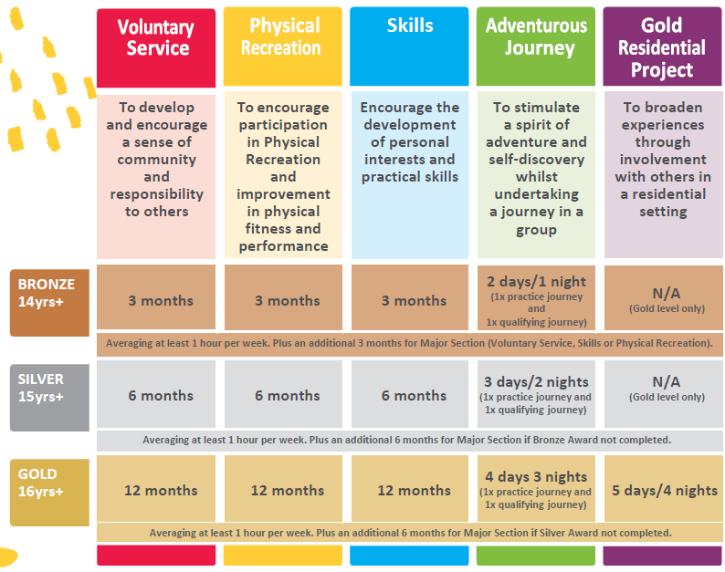

1.1 Key Requirements
A major section must be chosen for each Award level where a participant hasn’t completed a previous Award level. The major section is undertaken for an additional length of time. A Participant can choose their major section from Physical Recreation, Skills or Voluntary Service. The time taken varies dependant of on the Award level.
If the Participant is a direct entrant to Silver, they must be 15 years old to start the Award. If a young person started their Bronze Award at 13, they can continue and register for the Silver Award upon the approval of the Award Leader.
- Minimum time requirements are expressed in whole months, during which there must be regular commitment. Regular time commitment is defined as at least one (1) hour per week, two (2) hours per fortnight or a four (4) hours per four weeks.
- Participants are encouraged to continue their activities beyond the minimum time requirements.
- If a Participant is required to take a break (e.g. school holidays or exams) they may still count their previous activities toward their Award. Breaks are fine so long as the Participant shows regular commitment over the specified whole number of months required for the Award level they have chosen.
- The minimum length of time for undertaking Award activities are a condition of the Award – it is not possible to achieve an Award in a shorter time span by working more intensely.
Section Criteria (Image 1. B.)
 | Voluntary Service | The Voluntary Service Section of the Award encourages young people to volunteer their time to and understand the benefits of this Voluntary Service to their community. To connect with your community and give service to others and their communities.
 | Physical Recreation | The Physical Recreation Section of the Award encourages young people to participate in sport and other physical recreation for the improvement of health, wellbeing and fitness.
 | Skills | The Skills Section of the Award encourages the development of personal interests and practical and social skills
 | Adventurous Journey | The Adventurous Journey Section encourages a sense of adventure whilst undertaking a team journey or expedition. As part of a small team, participants will plan, train for and undertake a journey with a defined purpose in an unfamiliar environment.
 | Gold Residential Project (Gold Level only) | The Gold Residential Project, completed only at Gold level, aims to broaden Participants’ horizons through involvement with others in a residential setting.

As a non-formal education framework, the Award can play a vital role in providing opportunities for young people to develop essential life skills, increase their employability and foster their creativity and innovation.

1.2 WACE Achievement

The Award in WA is an endorsed program with the School Curriculum and Standards Authority and Year 10, 11 and 12 students can count the following unit numbers towards the WA Certificate of Education (WACE).
- Bronze: One unit
- Silver: Two units
- Gold: Four units
In addition, the Award:
- Will be listed on their Western Australian Statement of Student Achievement
- May contribute towards the breadth-and-depth requirement of the WACE
- May contribute towards the C grade requirement of the WACE.
For students that receive over 26 WACE units, they receive a certificate of acknowledgement for achieving above the expected standard.
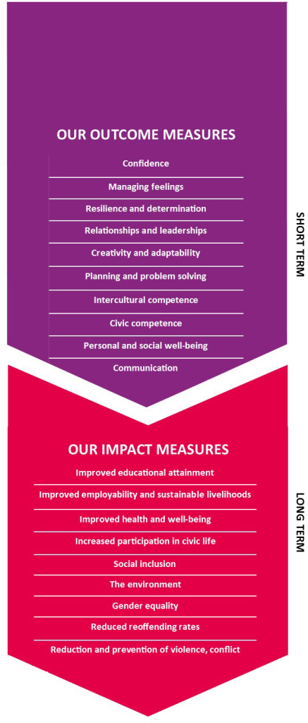
1.3 Outcomes
Through this challenging journey of self-discovery, Participants are:
- Are equipped and empowered to achieve their personal best;
- Learn to take responsibility for their goals and choices;
- Become connected to and actively engaged within their immediate community;
- Make a real difference to society through their positive contributions and involvement;
- Learn to persevere and overcome barriers to success;
- Learn important life skills; and
- Increase their career opportunities.

1.4 Key Design Features of The Award
1. Universal access via a licensing arrangement. Youth organisations, schools, sports organisations, clubs, institutions and government entities become licenced Award Centres and run the Award in their organisation. The Award is used by organisations to complement the activities that they currently provide (educational, recreational or community services) and/or it designed to extend on and recognise activities being undertaken.
2. Non-competitive. Young people under the guidance of their Award Leaders and Activity assessors select their activities and then set their own goal for each activity. An Award Participant cannot be “failed”. Showing continuous effort and meeting the key requirements such as duration and recording their activity will see them achieve their Award.
3. Balanced program of either 4 Sections (Bronze and Silver levels) or 5 sections (Gold level). This aspect of the Award’s design was strongly influenced by one of the Award’s founders Dr Kurt Hahn. An educational leader that had firsthand experience in the benefits in blending non formal education with the educational school rigors. The Award requires each Participant to undertake an activity that qualifies as:
- Voluntary Service: Volunteering time to assist others or your community
- Physical Recreation: Improving fitness and discovering new sports or active recreational activity
- Skills: Undertaken a new interest or hobby or extending on a current one
- Adventurous Journey: This is the only section of The Award required to be undertaken in a group. Undertaking a journey in an unfamiliar environment is about creating opportunities for team building through shared planning, role allocation, problem solving and accommodating physical and personality differences
4. Progressively more demanding levels. The 3 levels are progressively more demanding due to the longer duration required for each activity. The Award requires youth to acquire the discipline of planning their time, perseverance and communication (their colleagues and their activity assessor). The minimum age ranges recognise that the minimum time demands of the Award are more likely to be met as young people mature and gain resilience. Although most participants commence with the Bronze Award at 14, there is no obstacle in commencing the Silver Award directly if over 15 or the Gold if over 16.
5. Voluntary participation. The founders recognised that there are immediate and overall greater personal development benefits if a young person chooses to undertake an Award. In addition the substantial portion of the time required undertaking the selected activities must be done so in the participant’s own discretionary time, i.e. not part of a required school activity.
6. Duration is used to set the main challenge of the Award. There is not the option of completing any of the sections in a shorter duration despite how many hours above the minimum are actually achieved. As previously mentioned, time management and perseverance are key life skills acquired by Award Participants.
7. Recognition of achievement. Recording one’s activity, communicating with Award Leaders and activity assessors provide a very important source of ongoing feedback (positive and corrective) that is an essential fuel for personal development. In addition, the Award deliberately sought to have a high profile through adopting its identity with the co-founder, The Duke of Edinburgh. Countries subsequently taking up the Award have similarly sought a high recognisable and positive status name, e.g. The President’s Award. Today the Award’s brand is one of a highly respected and valued youth program. Employers, academics, youth works and community leaders all consistently sing the praises of the positive impact the Award makes with the most diverse groups of youth
- Our Involvement

  - Organisational Benefits of Delivering the Award
Delivering the Award brings your organisation many benefits, not least the opportunity to help develop young people and support them on their journey to a better future. By delivering the Award your organisation will:
  - Support your organisation’s strategy and specific goals
  - Greatly help to develop the lives of young people and their communities
  - Become part of an international network of Award Centres, Award Leaders and like-minded individuals and organisations
  - Complement existing extra-curricular activities that you provide and receive recognition for them
  - Give young people the opportunity to achieve the world’s leading youth Award.
The governance structure of the Award is based on a social franchise model using a multi-tier set of licences. As an international organisation, The International Award Foundation, governed by its Trustees has the overall responsibility of the Award. The International Award Association is a member organisation that facilitates the delivery of the Award through it member countries.
  - Participants
Open to young people aged 14 to 24, however for the Bronze Award; students can be 13 if they are enrolled in a year group with individuals of 14 years of age.
2.2 Coordinating the Awards
All participants are guided and supported by a network of trained adult Award Leaders, Assessors, Supervisors and Mentors.
Whilst it is up to the student to find their own Assessor, students will be provided with a list of extra-curricular activities on offer at the Award Centre that they can elect to complete as part of their chosen activities.
As the Award Leader, a key role is to be the main point of contact for the Award Centre, leading the implementation and delivery of students completing their Award.
As the Award Leader, roles and responsibilities include, but are not limited to the following:
- Planning and Monitoring the Implementation of the Award
- Contact person and mentor for Award Participants
- Planning and Activity Approvals of Participants
- Monitor and Record Keeping of Participants Progress
- Approval of Section(s) Completion
- Legal Administration Requirements (Funding, Promotion, Programming, Background Checks of Assessors, etc.).
- Program Timeline
Please provide details of how the program will operate within your Award Centre and the timeline for release.

