**Project Brief:**

*Increasing Completions & Continuations*

**The Duke of Edinburgh’s International Award - Australia**

Sofia Viegas & Johanna Leitch

June 2020

Version: 2.0



**Executive Summary**

**Background**

In the four-year period of June 2016 to June 2019 the Award completion rate increased from 41.3% to 44.7% *(statistics taken from 2018 number, updated 2019 statistic to be added when released)*. Whilst the target of 60% may be considered aspirational, there are currently no national initiatives directly targeting improvements to this area on the current National Strategic Plan. As such, we believe greater improvements are possible through this targeted strategic project.

This project is in support of:

* **The 2020 National Headline Goals**of a 60% completion rate and 50,000 new Award participant registrations each year, and future but-as-yet unset 2025 goals.
* **The 2025 National Strategic Plan –**‘Award Completion Management’ research project which sets out to determine the factors inhibiting retention, with the outcomes of this research to identify evidence-based actions to redress the attrition and premature cessation rates across Australia.
* **The 2020 Victorian Business Plan**‘*2.2 Completion & Continuation’*initiatives to increase quality and effectiveness of the Award

In 2018, at the Staff Conference held in Melbourne, the notion for greater attention afforded to the growth of completions and continuations of the Award across Divisions was loosely raised, with a consensus made on this matter but not yet actioned. In 2019, the Victorian Team commenced an official launch of a focused Completions and Continuations (C&C) Project leading into the National Staff Conference held in Sydney in 2019. Qualitative and quantitative research was undertaken in the months prior as part of Phase 1 of the C & C initiative, in establishing a snapshot of the current baseline practice across Australia to present to all Divisions.

Information presented at the conference, as per the National Staff Conference Report, demonstrated a strong demand for a targeted strategic approach to improving completions and continuations Australia-wide. It is as a result of the positive support from all Divisions that we move forward with the next phase of this project, in working to improve our capabilities in delivering and growing the Award, as well as creating more tailored and effective experiences for all involved in the Award.

**The What**

The *Completions and Continuations Project* is a 5 year long national project, led by the Victorian Division in partnership with the National office, which aims to increase participation in The Duke of Edinburgh’s International Award through the lifting of Award completion rates, and the increasing of Award continuation

rates. The project seeks to create an understanding of the current climate of practices pertaining to the growth of completions and continuations as carried out across each Division, in order to develop a sound best practice model for Australia-wide implementation, as informed through thorough research from various stakeholders involved in the Award experience.

**The Why**

This project assumes that the increasing of continuations and completions of the Award Australia-wide will lead to more positive Participant experiences, more tailored opportunities for Award involvement and success, and in turn, greater societal impact through enhanced Award value. As a national network, we are improving our capabilities in delivering and growing the Award, as well as creating more effective and beneficial experiences for all involved in the Award. In doing so, we are continually evolving as the leading youth development program, whilst also directly supporting the national strategic Headline Goals, Victorian Business Plan, and hopefully all Division’s Business Plans, through specifically targeting operational improvements to this area.

**The How**

The C&C Project will satisfy our aim of enhancing completions and continuations of the Award for our Participants through the following means:

* Establishing a clear understanding of current practice across Australia and NZ Divisions pertaining to increasing completions and continuations through qualitative and quantitative analysis
* Engaging representation from each division to conduct research with respective Award Centres, in order to capture a full picture of the national landscape
* Undertaking extensive discovery research regarding the challenges faced in increasing C&Cs and opportunities for improvement via interviews, focus groups and surveys with various Award users. These include, but are not limited to, Field Officers, Award Leaders, Participants, Assessors, and Alumni.
* Establishing a set of best practice initiatives committed to improving C&Cs across each Division, as informed by the above research undertakings, accompanied by monitoring and evaluation of their success over a 12-month period.

*\*Please refer to the full-length Research Plan document for a more detailed breakdown of time, resources and operational logistics of the Project\**

**The Outcome**

1. Establish a set of standard best practice procedures and protocols to ensure maintenance and steady growth of continuations and completions (operations that should be carried out as part of everyday practices in permanent staff roles)
2. To create a set of strategic initiatives to significantly lift the rate of completions and continuations over the next five years
3. To create a better understanding of, and commitment to, enhancing Award user experience through more consistent operational practices and initiatives between divisions and national teams

**Next Steps**

As we enter Phase 2 of the C&C Project, the next steps include:

1. Finalising a detail Project Plan for circulation to all relevant divisional staff members.
2. Engaging with Divisions to scope interest and involvement here forth in supporting the execution of this project.
3. Training and support given to Divisional staff who are interested in helping to conduct the research.
4. Research is initiated, as per the detailed plan outlined in the full-length Project Plan (please refer to Research Plan document for further information).
5. Based on these findings, key initiatives are to be adopted and rolled out across Divisions, and continually monitored and tested.
6. Measure and capture percentage of completions and continuations for each Division to establish effectiveness of baseline and best practice models.

# **Continuations and Completions – Full Project Brief**

# **Aim**

This project aims to increase participation in the Award by:

1. **Lifting the Award completion rate** in order to ensure that we maximise the societal impacts for people undertaking the award and encourage registration growth.
2. **Increasing continuations of** Award Holders undertaking a higher level of the Award, to encourage registration growth.

## **Business Case**

**Value Proposition:**

Based on the guiding principles of the Award: Achievable, Persistence and Progressive, we assume: Completions and subsequent continuations lead to Award growth and improve the societal impacts for Award Holders. In undertaking this project, we are working to generate a best practice model to be adopted and adapted across Divisions for higher performance pertaining to completions and continuations. In doing so, as a national network, we are improving our capabilities in delivering and growing the Award, as well as creating more tailored and effective experiences for all involved in the Award.

**Phase 1 Findings:**

Findings from Phase 1 (conducted in 2019) found a lack of consistency and regularity in strategies and initiatives to address and boost C&Cs. Some common ideas for strategic initiatives were raised, but many of these were broad, complex ideas, that require more thought and research to be able to form a clear structure or shape that could be rolled out across Divisions. These finding have informed the objectives of Stage 2 of this Project.



**Deliverables & Timeline**

To meet the Objectives of the project, and therefore achieve the Aim, it is envisaged that the following deliverables will be completed with the timeline below:

**Stage 1: Phases 1 – 3 (2020) - Already Completed**

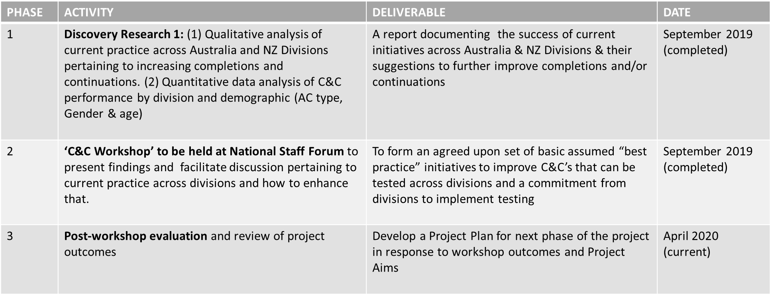

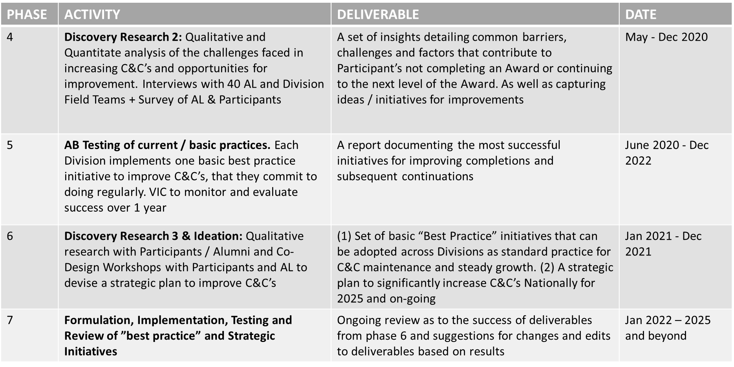**Stage 2: Phases 4 – 7 (2020-25**

## **Detailed Plan for Achieving Phases 4 & 5**

*Research Plan, Budget, Resources & Divisional Engagement*

*This section pertains only to phases 4 & 5, as they are the phases conducted within the next 2 years. For a full account of each phase, please consult the full project plan.

**Research Plan**

**Phase 4 (May – December 2020)**

* **Step 1: AL + Participant Survey (Quantitative method) – proposed date July – September 2020**
  + VIC in partnership with National to design, distribute & analyse surveys to three groups: current ALs, Participants and Alumni:
    - Surveys aim to identify WHAT are the most common and problematic *reported* challenges or roadblocks to continuations and completions, from the perspective of each of those three groups
    - Qualitative Interviews are then used to find out WHY & HOW these challenges affect continuations and completions
    - Surveys to be incentivised if response does not reach a statistically significant number which is at least 100 from each group
    - Surveys to be analysed and findings reported on by National in partnership with VIC
* **Step 2: 40 X 1:1 interview with Award Leaders (AL) – proposed time window October – November 2020**
  + Qualitative Interviews aim to follow up on findings from the quantitative survey analysis to gain a better understanding of why these findings are taking place. For example, they are used to:
    - Identify WHY & HOW common reported challenges / roadblocks affect continuations and completions
    - Identify user (Participant + AL) needs & motivations
    - Formulate strategies to meet needs and solve challenges
  + The interview group would be made up of ALs from each Division. Interviewees would be recruited through the quantitative surveys. Estimates as follows:
    - NSW = 12 ALs
    - VIC = 12 ALs
    - SA = 11 ALs
    - QLD = 11 ALs
    - TAS = 11 ALs
    - WA = 11 ALs
    - ACT = 11 ALs
    - NT = 11 ALs
  + The interview group would also consist of a mix of ALs from independent, government, regional, metropolitan and specialist schools. The proportion of each groups selected should reflect true proportions of these Award Centres nationally
  + Ideally Divisional staff would interview the ALs selected from their Division. Staff would be trained and supported to be able to execute this
* **Step 3: Feedback, Synthesis & Insights – proposed date November – December 2020**
  + Interview de-brief / playback: Key findings from each Division’s interview group would be presented back to the larger working group or representatives from the State and Divisional representatives
  + VIC to take key findings from each Division’s interview groups and synthesise to find common themes / findings
  + VIC to develop the findings and synthesise into a set of tangible insights
* **Step 4: Combined Synthesis + Insights**
  + VIC in combination with National to synthesise the findings from the quantitative and qualitative research and develop a set of insights

**Phase 5 (June 2020 – Dec 2022)**

* **Step 1: Divisional Consultation to identify baseline practices – Proposed date July – August 2020**
  + Aim to establish agreed baseline / basic best practices to address C&C’s, that can be rolled out across Divisions and practiced with consistency and regularity
    - Each Division’s EO + Field team is consulted and asked to list their top 3 basic practices they could adopt tomorrow
    - VIC collects this info from each Division and identifies the most common (and doable) 3-5 practices that will become the basic best practices to be adopted
* **Step 2: Measure – Proposed Date September 2020**
  + Before practices are adopted, a measurement of C&C’s performance, by Division and Nationally, over the previous year, is recorded
* **Step 3: Adopt, Implement and Monitor - Proposed Date September 2020 – onwards** 
  + Divisions implement practices with regularity and consistency
  + Divisions have from September 2020 – Dec 2020 to practice and pilot practices before they are rolled out over the testing period
  + VIC / Working Group to check in monthly that practices are being conducted
  + VIC / Working Group to obtain & record feedback about challenges implementing practices
* **Step 4: Measure & Compare - January 2021 – January 2022**
  + Measure percentage of completions and continuations for each Division over period 2021-2022
  + Compare this to the percentage of C&C’s between 2019-2020 and 2021-2022
  + Report on the effectiveness of the baseline / basic best practices that were implemented

**Budget & Resources**

The main budget and resources for the project comes from staff engagement and hours. Some travel costs and budget for incentivising research participation may also be needed, if funds are available.

**Hours / Staff**

**Phase 4:**

* Research Participation Recruitment: 7- 20 hours
* Conducting Interviews: 50-110 hours
* Interview Playback: 16 – 20 hours
* Project administration and coordination: 10 hours
* Synthesis + Insight: 15- 20 hours

Total = 100 hours - 180 hours / 3 weeks full time work – 5-week full time work

**Phase 5:**

* Divisional Consultation + Synthesis of findings: 7- 20 hours
* Measurement: 2-3 hours
* Implementing and Adopting Practices: unknown + ongoing (ideally becomes part of staff’s normal role / activities)
* Monitoring and Evaluating: 84 - 168 hours (monthly check-ins with each Division, 1 hour spent checking in with each Division over a year)

Total = approx. 191 hours / 5 weeks full time work

**Travel Costs:**

In light of post-pandemic, we consider here the feasibility of conducting meetings and engagements over online platforms, as opposed to face-to-face travel. Not only will this enable more streamlined accessibility for all participants of the research, it will also help to minimise travel expenses. Should travel be required, such as the potential of interstate trips by VIC staff to support Divisions with less resources, such as Tasmania and ACT, these expenses can be incorporated into existing field visits and travel budgets at a Divisional level. In the case where travel would be necessary, we would try to conduct as many interviews as possible within the one visit. We expect for associated travel costs to be very low.

**Incentive Budget**

There is currently no budget allocated for incentivising the research. If an incentive is needed to increase survey response numbers or to recruit Award Leaders & Young People for interviews / workshops, this cost will need to be absorbed by divisions where they deem necessary.

**Divisional Engagement**

**Hours / staff**

**Cost of people hours / staff engagement to be absorbed by Divisions.**

Phase 4

Hours: Approx. 15-30 hours per Division

* Ideally each Division would participate in recruiting for and conducting the 1:1 interviews with the Award Leaders selected from their Division:
  + AL interview recruitment: 1-5 hours
  + Training: 1-2 hours
  + Interviews: max 12 hours (1hr / interview)
  + Interview Playbacks: 2-4 hours
  + Meetings to present interview & synthesise findings (passive participation): 10 hours

Phase 5

Hours: Approx. 18+ hours per Division

* Ideally each Division would make time to be consulted on basic practices and would agree to adopt the practices identified as the most popular / deemed most valuable (VIC will ensure practices will not be incorporated into the final set if it’s not achievable / feasible to be rolled out by each Division). If a Division is not open to participating in this phase of the research, measurement would exclude this Division’s C&C’s from the final numbers. This Divisions C&C’s could still be measured and used as a control group to compare the final numbers from other Divisions to
  + Consultation: 1-2 hours
  + Implementation: unknown (ideally becomes part of staff members’ normal roles / activities)
  + Check-ins: 12 hours max (1 hour / month)
  + Reporting: 2-4 hours

**Incentive for Participation in Project**

* Strategies developed will be better tailored to each Division and the needs of their Award Centres, Leaders and Participants.
* Conducting 1:1 interviews will help strengthen your relationships with your Award Leaders. Research shows consulting your clients in decision making and strategy development greatly improves customer loyalty and engagement and your relationship with them
* Training is an increasingly valued skill set (design research and customer experience design) which will look great on your CV and help future proof your career

**Next Steps**

As we enter Phase 2 of the C&C Project, the next steps include:

1. Finalising a detail Project Plan for circulation to all relevant Divisional staff members.
2. Engaging with divisions to scope interest and involvement here forth in supporting the execution of this project.
3. Training and support given to Divisional staff who are interested in helping to conduct the research.
4. Research is initiated, as per the detailed plan outlined in the full-length Project Plan (please refer to Research Plan document for further information).
5. Based on these findings, key initiatives are to be adopted and rolled out across divisions, and continually monitored and tested.
6. Measure and capture percentage of completions and continuations for each division to establish effectiveness of baseline and best practice models.