Merchandise Discount Schedule
March Timeline | Best Day to Promote | Mode of Communication | Message
Week 1  (1st – 9th March) | Monday 4th March | EDM – Direct Email to All Award Units/Award Leaders/Participants | Discounts on Award Hats and Polo shirts for March
 | Tuesday 5th March | Social Media Post  (Facebook/Instagram/Twitter) | Discounts on Award Hats and Polo shirts for March
 | Thursday 7th March | Social Media Post  (Facebook/Instagram/Twitter) | Discounts on Award Hats and Polo shirts for March
Week 2  (10th – 16th March) | Tuesday 12th March | EDM – Direct Email to All Award Units/Award Leaders/Participants | 3 Weeks to go!
 | Wednesday 13th March | Social Media Post  (Facebook/Instagram/Twitter) | 3 Weeks to go!
Week 3  (17th –23rd March) | Tuesday 19th March | EDM – Direct Email to All Award Units/Award Leaders/Participants | 2 weeks to go!
 | Thursday 21st March | Social Media Post  (Facebook/Instagram/Twitter) | 2 Weeks to go!
Week 4  (24th – 31st March) | Tuesday 26th March | EDM – Direct Email to All Award Units/Award Leaders/Participants | Last week of discounts!
 | Wednesday 27th March | Social Media Post  (Facebook/Instagram/Twitter) | Last week of discounts!
 | Thursday 28th March | Social Media Post  (Facebook/Instagram/Twitter) | 3 days to go!

*Tips for Social Media Posting - Posting on a Tuesday, Wednesday, Thursday in late afternoon (4 - 5 pm) often receives the best responses, reach and engagement.
*For those without Social Media pages, you can double up on direct emails, using the Social Media graphics within an email.
Week 1 Communication: 1st – 9th March
EDM – Direct email to all Award Units/Award Leaders/ Participants
in your State or Territory
Message:
SPECIAL OFFER – ONE MONTH ONLY!
For the month of March, we would like to offer all Award Units, Award Leaders and Participants 20% off Award Hats AND Polo Shirts!
Award Hats and Polo Shirts are a perfect addition for your next Adventurous Journey or even to wear for your Physical Recreation Activity.
Buy yours today at www.dukeofedstore.com.au
Please find attached a flyer to distribute to your Award Participants.
For more information on Award merchandise, contact comms@dukeofed.com.au
Graphic (optional):
*Option to hyperlink to our Store Website www.dukeofedstore.com.au
*Display at bottom of email
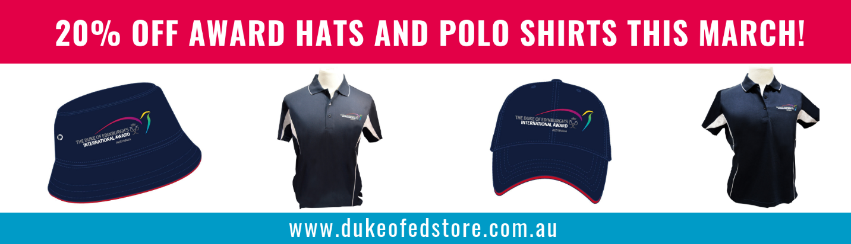

*Remember to attach flyer

Social Media Post 1 – Facebook/Instagram/Twitter
Message:
SPECIAL OFFER – ONE MONTH ONLY!
For the month of March, we would like to offer all Award Units, Award Leaders and Participants, 20% off Award Hats AND Polo Shirts!
Award Hats and Polo Shirts are a perfect addition for your next Adventurous Journey or even to wear for your Physical Recreation Activity.
Buy yours today at www.dukeofedstore.com.au
For more information on Award merchandise, contact comms@dukeofed.com.au
#dukeofedaus #dukeofedstore #merchandise #hats #shirts #discounts
Graphic:
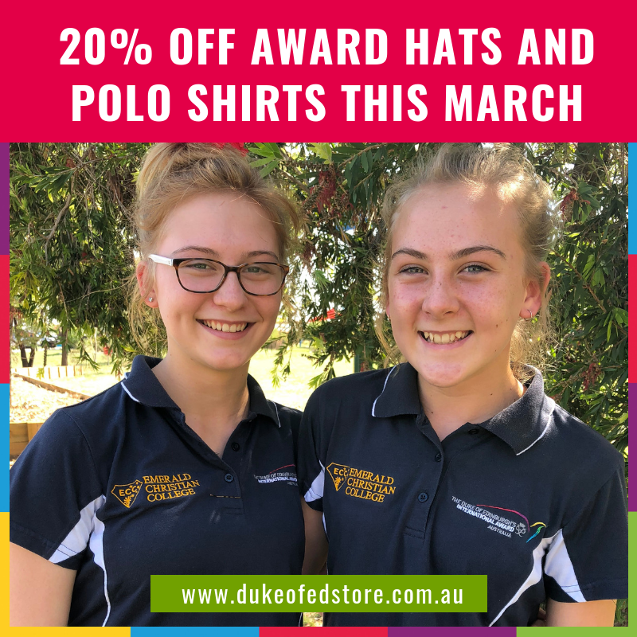

Social Media Post 2 – Facebook/Instagram/Twitter
Message:
20% off Award Hats and Polo Shirts – GRAB ONE BEFORE THEY SELL OUT!
For the month of March, we would like to offer all Award Units, Award Leaders and Participants 20% off Award Hats AND Polo Shirts!
Perfect to wear for your next Adventurous Journey, for your Physical Recreation or your Voluntary Service Activity!
Buy yours today at www.dukeofedstore.com.au
For more information on Award merchandise, please contact comms@dukeofed.com.au
#dukeofedaus #dukeofedstore #merchandise #hats #shirts #discounts
Graphic:

Week 2 Communication: 10th – 16th March

EDM – Direct email to all Award Units/Award Leaders/Participants
in your State or Territory
Message:
Discounts on Award Hats and Polo Shirts – 3 WEEKS TO GO!
This March, we would like to offer all Award Units, Award Leaders and Participants 20% off Award Hats AND Polo Shirts!
Award Hats and Polo Shirts are a perfect addition for your next Adventurous Journey or even to wear for your other Award Sections such as Physical Recreation or Gold Residential Project.
Buy yours today at www.dukeofedstore.com.au
Please find attached a flyer to distribute to your Award Participants.
For more information on Award merchandise, contact comms@dukeofed.com.au
Graphic (optional):
*Option to hyperlink to our Store Website www.dukeofedstore.com.au
*Display at bottom of email

*Remember to attach flyer

Social Media Post – Facebook/Instagram/Twitter
Message:
Discounts on Award Hats and Polo Shirts – 3 WEEKS TO GO!
This March, we would like to offer all Award Units, Award Leaders and Participants 20% off Award Hats AND Polo Shirts!
Award Hats and Polo Shirts are a perfect addition for your next Adventurous Journey or even to wear for your other Award Sections such as your Physical Recreation or Gold Residential Project.
Buy yours today at www.dukeofedstore.com.au
For more information on Award merchandise, contact comms@dukeofed.com.au
#dukeofedaus #dukeofedstore #merchandise #hats #shirts #discounts
Graphic:

Week 3 Communication: 17th – 23rd March

EDM – Direct email to all Award Units/Award Leaders/Participants
in your State or Territory
Message:
Discounts on Award Hats and Polo Shirts – 2 WEEKS TO GO!
This March, we would like to offer all Award Units, Award Leaders and Participants 20% off Award Hats AND Polo Shirts!
Award Hats and Polo Shirts are a perfect addition for your next Adventurous Journey or even to wear for your other Award Sections such as your Physical Recreation or Voluntary Service Activity.
Buy yours today at www.dukeofedstore.com.au
Please find attached a flyer to distribute to your Award Participants.
For more information on Award merchandise, contact comms@dukeofed.com.au

Graphic (optional):
*Option to hyperlink to our Store Website www.dukeofedstore.com.au
*Display at bottom of email

*Remember to attach flyer

Social Media Post – Facebook/Instagram/Twitter
Message:
Discounts on Award Hats and Polo Shirts – 2 WEEKS TO GO!
This March, we would like to offer all Award Units, Award Leaders and Participants 20% off Award Hats AND Polo Shirts!
Award Hats and Polo Shirts are a perfect addition for your next Adventurous Journey or even to wear for your other Award Sections such as your Physical Recreation or Voluntary Service Activity.
Buy yours today at www.dukeofedstore.com.au
For more information on Award Merchandise, contact comms@dukeofed.com.au
#dukeofedaus #dukeofedstore #merchandise #hats #shirts #discounts

Graphic:

Week 4 Communication: 24th – 31st March
EDM – Direct email to all Award Units/ Award Leaders/ Participants
in your State or Territory
Message:
Discounts on Award Hats and Polo Shirts – FINAL WEEK!
This March, we would like to offer all Award Units, Award Leaders and Participants 20% off Award Hats AND Polo Shirts!
Award Hats and Polo Shirts are a perfect addition for your next Adventurous Journey or even to wear for your other Award Sections such as your Physical Recreation or Voluntary Service Activity.
Buy yours today at www.dukeofedstore.com.au
Please find attached a flyer to distribute to your Award Participants.
For more information on Award merchandise, contact comms@dukeofed.com.au
#dukeofedaus #dukeofedstore #merchandise #hats #shirts #discounts

Graphic (optional):
*Option to hyperlink to our Store Website www.dukeofedstore.com.au
*Display at bottom of email

*Remember to attach flyer

Social Media Post – Facebook/Instagram/Twitter
Message:
Discounts on Award Hats and Polo Shirts – 5 days to go!
This March, we would like to offer all Award Units, Award Leaders and Participants 20% off Award Hats AND Polo Shirts!
Award Hats and Polo Shirts are a perfect addition for your next Adventurous Journey or even to wear for your other Award Sections such as your Physical Recreation or Voluntary Service Activity.
Buy yours today at www.dukeofedstore.com.au
For more information on Award merchandise, contact comms@dukeofed.com.au
#dukeofedaus #dukeofedstore #merchandise #hats #shirts #discounts

Graphic:

Social Media Post – Facebook/Instagram/Twitter
Message:
Discounts on Award Hats and Polo Shirts – 3 DAYS TO GO!
This March, we would like to offer all Award Units, Award Leaders and Participants 20% off Award Hats AND Polo Shirts!
Award Hats and Polo Shirts are a perfect addition for your next Adventurous Journey o even to wear for your other Award Sections such as your Physical Recreation or Service Activity.
Buy yours today at www.dukeofedstore.com.au
For more information on Award merchandise, contact comms@dukeofed.com.au
#dukeofedaus #dukeofedstore #merchandise #hats #shirts #discounts

Graphic:
Option 1:

Option 2:

