**COMMUNICATIONS FOR DISTRIBUTION - 60KM CHALLENGE**

**Audience: Email to Alumni and Award Participant over 18**

**Subject:** Join Australia’s First Duke of Ed Gold Awardee on a 60km Challenge!

**Date:** 13th February – 31st March 2019

**Prepared By:** Alex Zappia

**Authorised by:** Peter Kaye



**JOIN AUSTRALIA’S FIRST GOLD AWARDEE TO CELEBRATE THE 60TH ANNIVERSARY OF THE AWARD IN AUSTRALIA!**

Michael Dillon AM achieved his Gold Award in 1962 as Australia’s first Gold Awardee and was presented his Certificate by HRH Prince Phillip in 1963. Since completing his Award, Michael has accomplished a lot in his life becoming one of Australia’s leading cinematographers and makers of adventure and expedition documentaries, having won more awards in his field than any other individual worldwide. Over the years he has continued to be involved with the Award, encouraging young Participants to challenge themselves and achieve their goals.

Michael has now set himself a new challenge in 2019 to celebrate 60 years of the Award in Australia by undertaking a 60km challenge. He would like to invite Award Alumni or any person involved with the Award over the age of 18, to join him in his challenge!

**WHAT IS THE CHALLENGE?**  
Michael will hike 60 kilometres, one kilometre for every year the Award has operated in Australia.

**WHEN AND WHERE?**  
The 2019 Easter long weekend (19th April – 22nd April 2019), in the Hanging Rock, Mount Macedon Region, near Melbourne.

Those interested in finding out more information and how to register for the challenge, please contact Michael directly at [mcdillon@ozemail.com.au](mailto:mcdillon@ozemail.com.au)



**EMAIL EXAMPLE (OUTLOOK)**

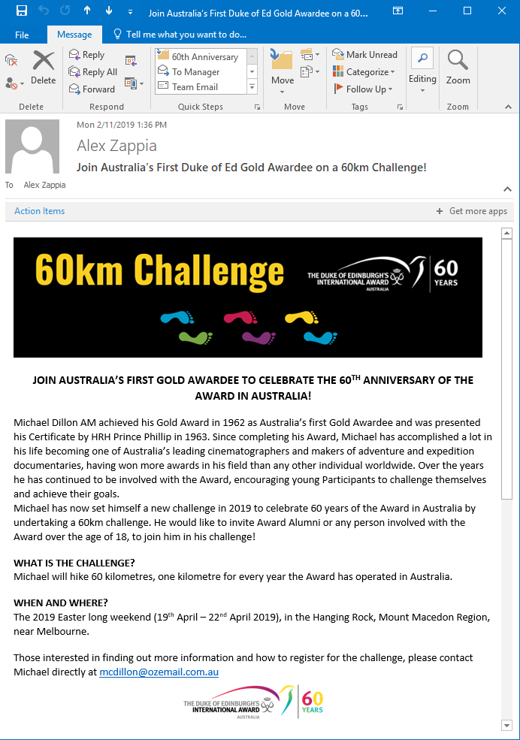

**EMAIL EXAMPLE (MAILCHIMP)**

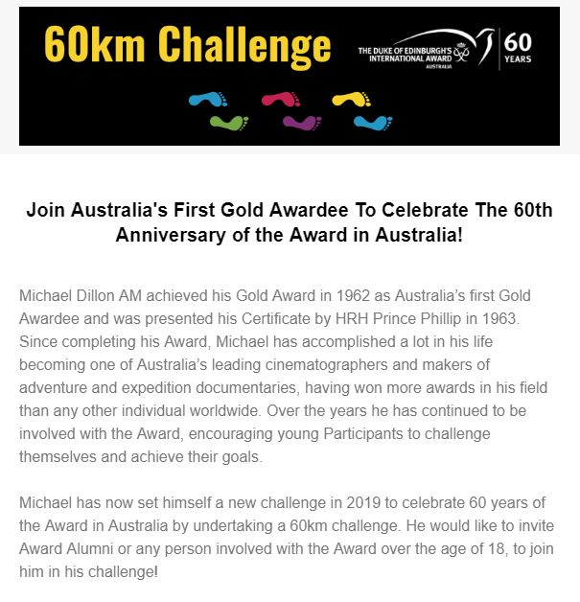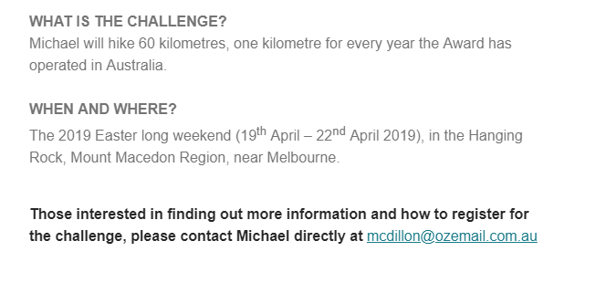 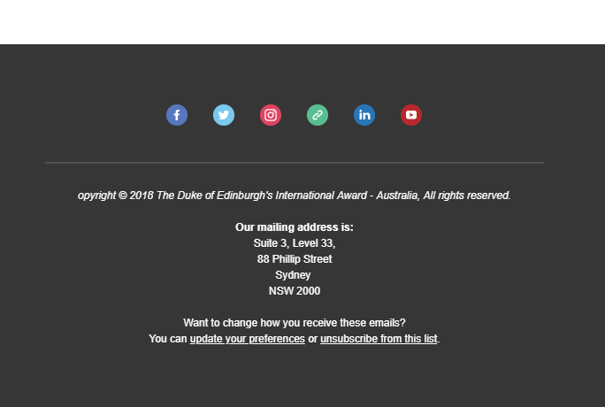

**SOCIAL MEDIA POST TEMPLATE**

**CAPTION:**

JOIN AUSTRALIA’S FIRST GOLD AWARDEE TO CELEBRATE THE 60TH ANNIVERSARY OF THE AWARD IN AUSTRALIA!

Over the Easter Long Weekend this year, Michael Dillon AM, Australia’s first Gold Awardee has set himself a challenge in 2019 to celebrate 60 years of the Award in Australia by undertaking a 60km challenge.

He would like to invite Award Alumni or any person involved with the Award over the age of 18, to join him in his challenge!

WHAT IS THE CHALLENGE?  
Michael will hike 60 kilometres, one kilometre for every year the Award has operated in Australia.

WHEN AND WHERE?  
The 2019 Easter long weekend (19th April – 22nd April 2019), in the Hanging Rock, Mount Macedon Region, near Melbourne.

To find out more information and how to register for the challenge, please contact Michael directly at [mcdillon@ozemail.com.au](mailto:mcdillon@ozemail.com.au)

#dukeofed #dukeofedaus #60kmchallenge #celebrating60years

**GRAPHIC OPTIONS:**

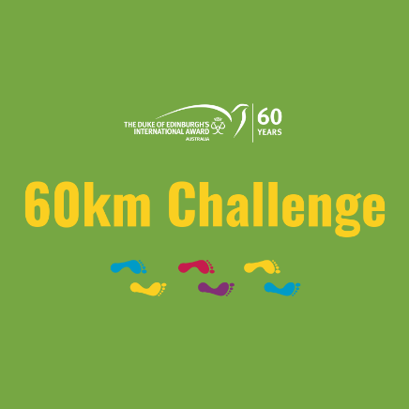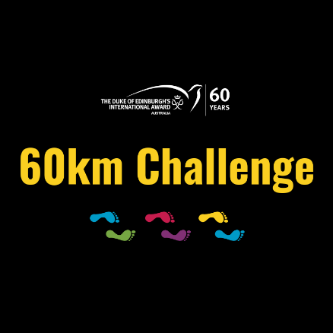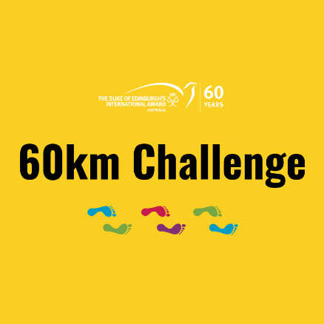

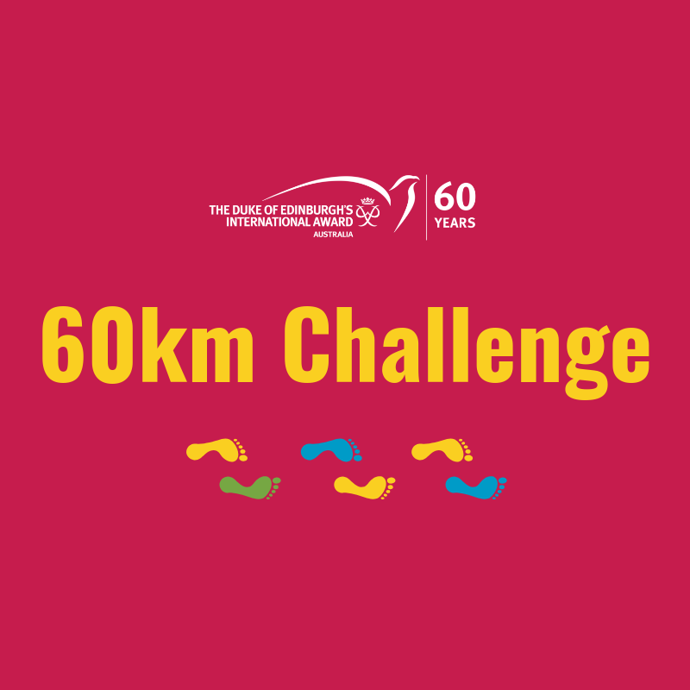

**POST EXAMPLE (FACEBOOK)**

