WE INVITE YOU TO ATTEND
A Celebration of the 60th Anniversary of The Duke of Edinburgh’s International Award - Australia
Help us celebrate the history of the Award and recognise the incredible hard work of the many volunteers and supporters, who have contributed to its success!
When:
Time:
Where:
Dress:

RSVP:

Questions:
E: P:
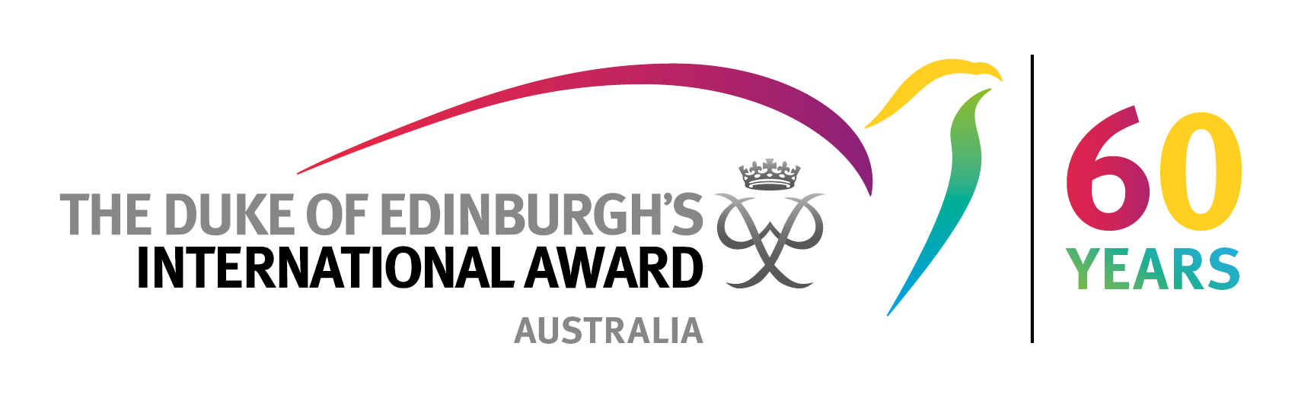
Put logo here

Images of you and any minors under your supervision may be photographed or filmed at any time throughout this event. By attending the event you are consenting to The Duke of Edinburgh’s International Award – Australia using and publishing these images for our promotional purposes. Note that we are not able to control the conduct of third parties who access the images online and whether they comply with the Privacy Act. Should you not wish to have your image photographed or filmed, please inform a member of staff at the event. See our Privacy Policy at dukeofed.com.au (or on request) for further details about how we collect, use and disclose personal information and how you can access and update your personal information and make a privacy complaint.

