**COMMUNICATIONS FOR DISTRIBUTION**

**Audience: Email to Award Units to notify them of the Award’s 60th Anniversary**

**Subject:** Help The Duke of Ed Celebrate it’s 60th Anniversary!

**Date:** 1st February 2019

**Prepared By:** Alex Zappia

**Authorised by:** Peter Kaye

**Version:** 1.0

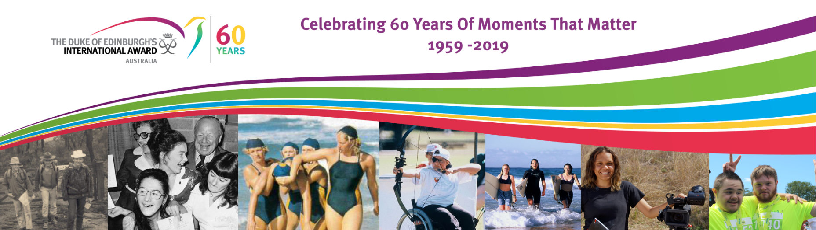

The Duke of Edinburgh’s International Award – Australia celebrates it’s 60th Anniversary this year and we invite you to join in the celebrations by shouting out about the Award and encouraging your Participants to join the celebrations and share their Award Stories!

*To help us celebrate, your Award Unit can use the following content to let your network know about the Awards 60th Anniversary:*

**This year, The Duke of Edinburgh’s International Award - Australia will celebrate 60 years of empowering young people to find their purpose, passion and place in the world and equipping them for work and life. …in other words, making them WORLD READY!**

**Since it’s inception in 1959, over 775,000 young Australians have challenged themselves to take on the Award. The Award in Australia recognises that its success is primarily attributable to the contributions of the tens of thousands of volunteers over the past 60 years, including the current network of over 60,000 volunteers.**

**Join the Celebrations by sharing you Award Story at** [**comms@dukeofed.com.au**](mailto:comms@dukeofed.com.au)

Follow our 60th Anniversary Celebrations and events on our [Website](https://dukeofed.com.au/events/60th-anniversary/) and Social Media!

[https://www.facebookbrand.com/img/fb-art.jpg](https://www.facebook.com/TheDukeofEd)    [Image result for linked in logo](https://www.linkedin.com/company/the-duke-of-edinburgh's-international-award---australia/)   [http://www.vanderbilt.edu/recreationandwellnesscenter/wellness/wp-content/uploads/Twitter-logo2.png](https://twitter.com/thedukeofed)   [cid:image020.png@01D404A2.434BA130](https://www.instagram.com/dukeofedaus/)   [Image result for square youtube logo](https://www.youtube.com/channel/UCiR3cXau0RhBhlnxeUKGVhQ/featured)