2017 APEC Voices of the Future Report
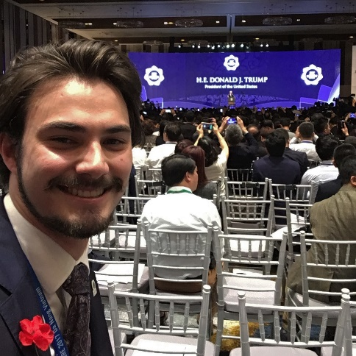
Robert Deppeler Australian Delegate
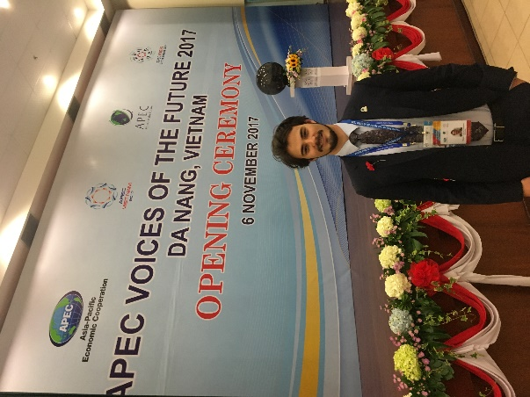
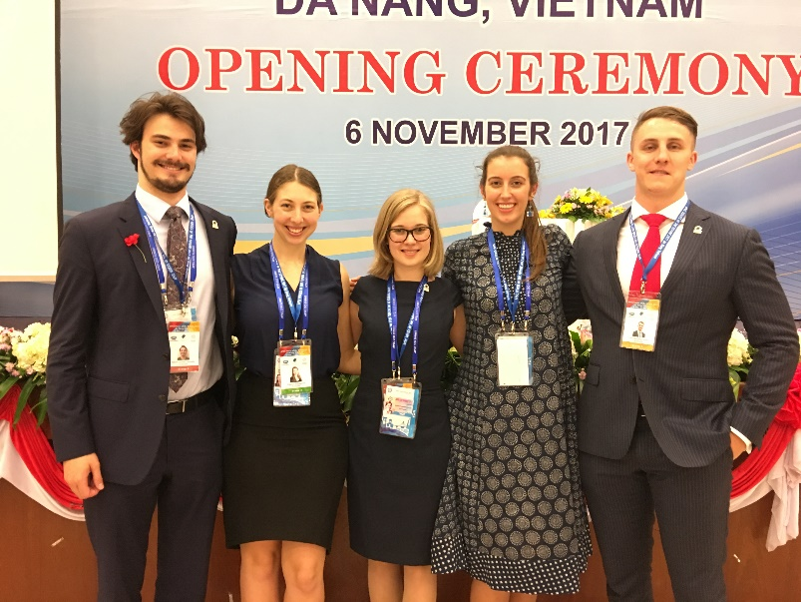
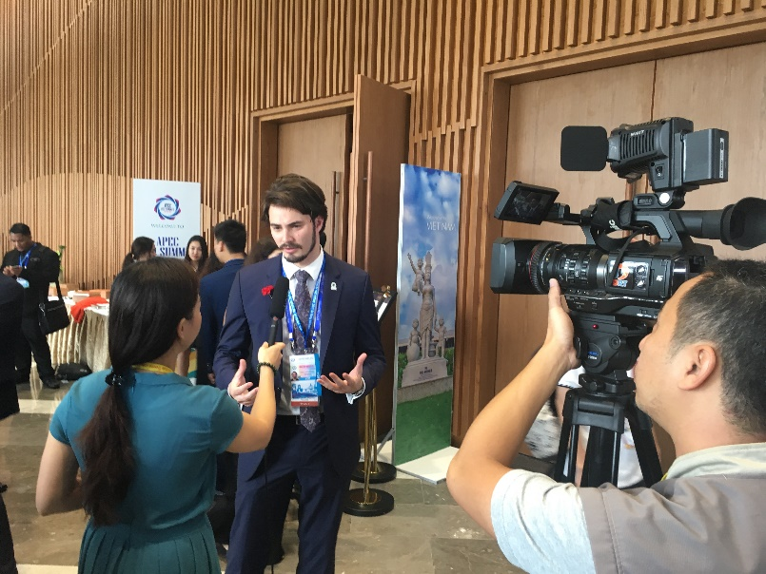
To attempt to sum up the experiences of the 2017 APEC Voices of the Future Conference in Da Nang Vietnam, is at both a challenging and almost surreal experience. Trump, Duterte, Xingping. These are all names that for me represent the pinnacle of global politics, and whilst perhaps I focus on these individuals for the immense power they hold over their respective nations, to say that hearing them speak, put forward their views on the future of our region, was the most influential part of my experience through the Duke of Edinburgh’s program, would be wrong.

Friends, Culture, Immersion.
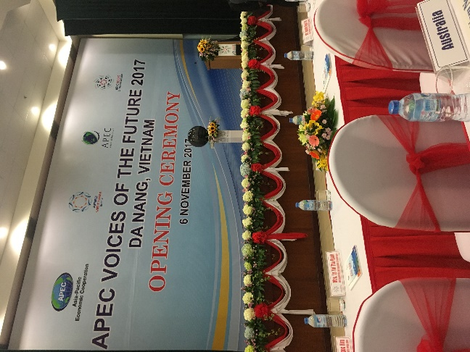
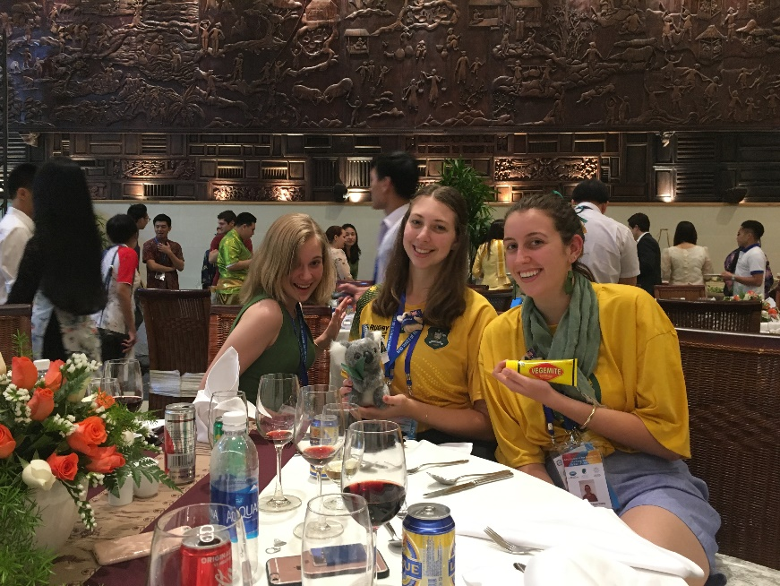
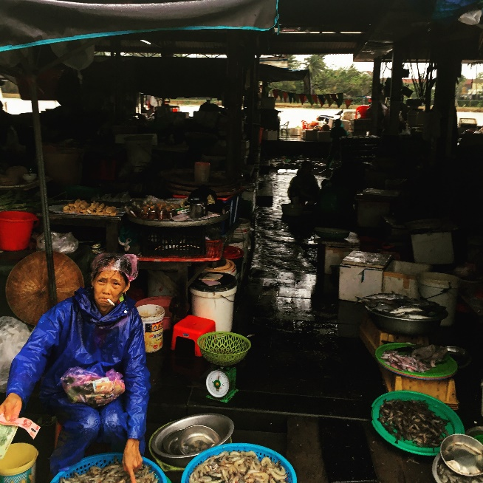
The 2017 APEC Voices of the Future program can be epitomised not by the names of the speakers, but by the friends made, the cultural experiences that are available and the immersion in a world so entirely different to any I had ever experienced. To be thrust into the limelight as an Australian Delegate is truly a daunting experience, perhaps most aptly captured by one of many interviews I had, in which expecting a question about the Youth’s role in the APEC region, my interviewer, with a wry smile asked whether I was brave enough to drive in Vietnam. Perhaps it was the humanising element of this simple question, but I was completely caught off guard, and I can think of no better way to describe the overall experience afforded to me, one that challenged me and in reflection, which I believe has changed the way I view the future of our Region.
17 Economies: 121 Friends
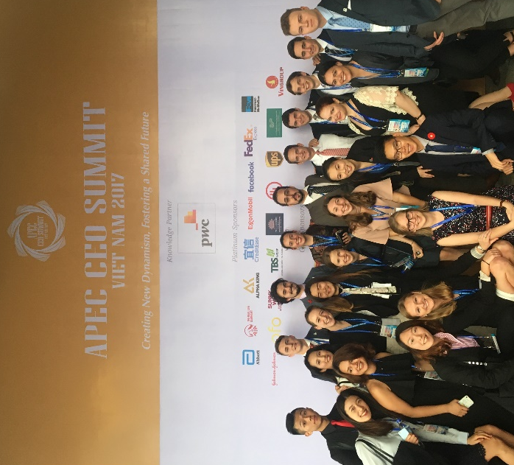
Prior to leaving for Vietnam I read the reports submitted by those who were fortunate enough to be chosen for the 2016 program, and almost sceptically laughed off the idea that in five days a group as large as the VOF delegates could resemble anything near friends. I was wrong.
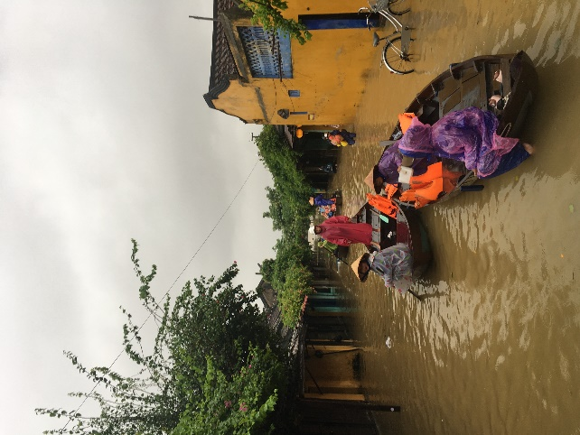
To talk to people from such diverse backgrounds yet find common ground in quaint and quirky areas was remarkable. I found that the group at the 2017 Voices of the Future Conference to be some of the warmest and friendliest individuals I have ever met, a group at once effortlessly easy to talk to yet fiercely intelligent. If this is a taste of the youth of our Region then I have no doubt of the impact it will make.
To Bánh Mì or not to Bánh Mì
As my first experience not only in Vietnam but South East Asia more generally, the opportunity to participate in the Voices of the Future Program allowed me to experience a unique and vibrant culture unlike any I had been immersed in. Whilst the tragedy of Typhoon Damrey acted as a sobering reminder of the realities of natural disasters on those communities it affects, to see a community united following this hardship was remarkable.
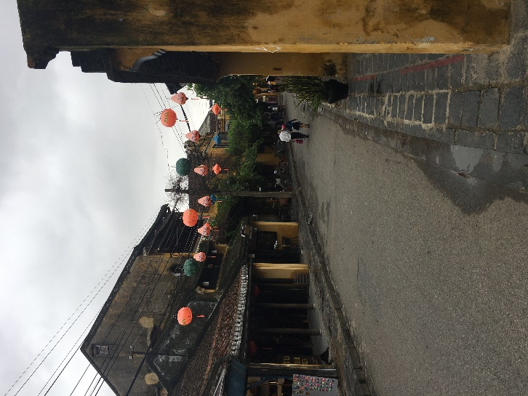
With smiles on faces motorbikes were swapped for boats, Nón lá (Traditional Hats) for rain ponchos, and yet nothing could dampen the generosity and friendliness of all of the people we met. Food, scenery and cultural performances all blurred into one and whilst only a short time, I felt as if I left knowing not only that I would one day return, but that I understood the country better than I could have on any holiday.
Diplomat for a week
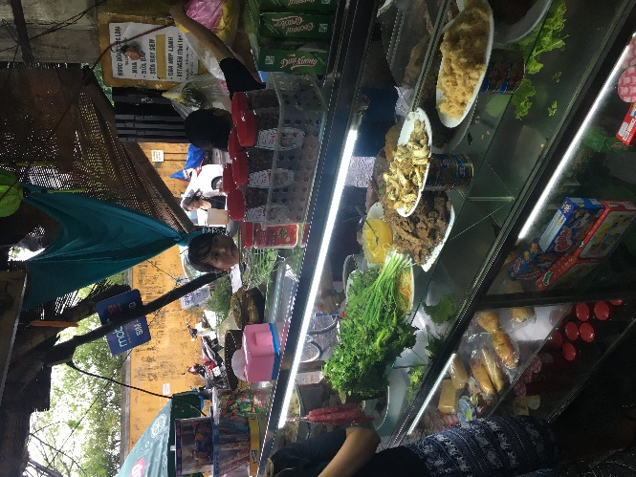
Perhaps the most significant experience that this opportunity presented me however was the ability to challenge myself, and when in a room surrounded by some of the most astute individuals from every member economy it is easy to feel challenged. To represent Australia, to act as a spokesperson for this nation, for our goals and policy was something that I never thought I would be able to do, let alone be doing at 20. To be immersed in such an environment is something that I could never have imagined as within reach, and without the continued support of the Duke of Edinburgh’s Award would not have been a reality for any of the Australian delegates who have been fortunate enough to have been chosen over these past many years.
The opportunity exceeded every expectation I held prior to going, and I wish to thank both the Duke of Edinburgh’s Award and all of my fellow Australian Delegates for making this such an unforgettable experience.

