2017 APEC Voices of the Future Report
By Georgia Eccles - Youth Delegate for the Economy of Australia
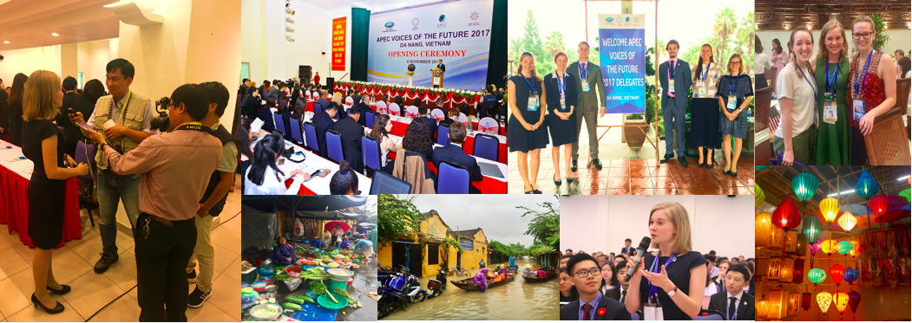

APEC Voices of the Future Forum and CEO Summit

On the 6th of November, the Australian youth delegation journeyed from Hoi An to Da Nang. The vibe was one of excitement and anticipation as four APEC-registered buses transported seventy-five youth delegates from 17 member economies to participate in the Voices of the Future forum.

At Da Nang University, we spent the day discussing the agenda for the 2017 theme “Creating New Dynamism, Fostering a Shared Future”. Following speeches from each member economy, Dr Noeleen Heyzer, presented an inspiring address. In the afternoon, myself and the 20 other Declaration drafters had the honour of facilitating the consultation of all seventy-five youth attendees. For most of the evening and the following morning, us drafters wrote a two-page statement reaffirming the importance of embracing innovation and that all of society in the Asia-Pacific region was financially literate. This Declaration, asserting the perspective of the millennial generation, was presented to the leader of each of the member economies upon their arrival in Vietnam.

The atmosphere of unity and commitment for the future of inclusive economic growth was tangible at the APEC CEO Summit. It was here that I heard from notable economic figures such as, the President of Peru, the Prime Minister of New Zealand and the Global CEO of Johnson & Johnson.

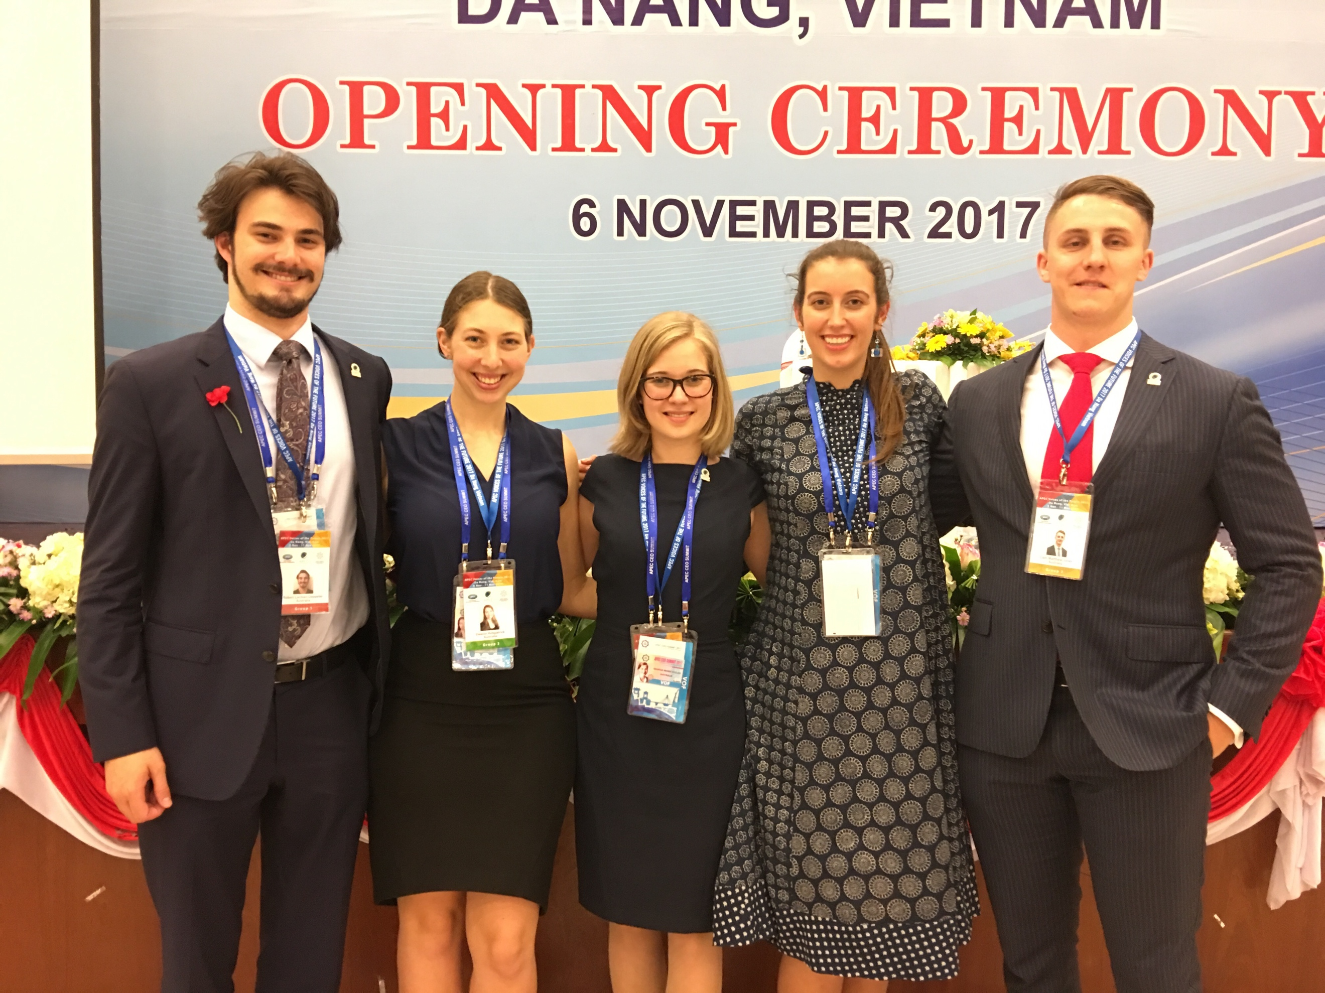

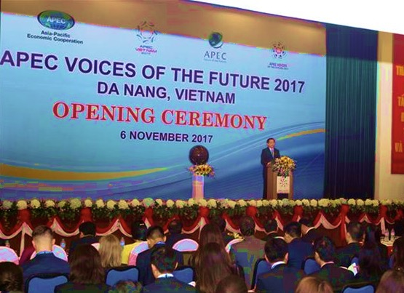

Quang Nam Province, Vietnam

In addition to the conference economic discourse, us youth delegates experienced an incredibly welcoming, generous and sensory experience exploring the Quang Nam Province. Despite Typhoon Damrey devastating the region only days earlier, the people of Vietnam were incredibly eager to show us the treasured aspects of the region. On Tuesday the 7th of November, we departed Hoi An for the Quang Nam Peace Village. It was here that we were treated to a wonderful performance by the resident children from the Peace Village. The Australian, Mexican and Canadian delegates than taught the children a series of nursery rhymes and dances. Following this visit, we journeyed to the Tam Thanh Mural Village. The villagers were incredibly hospitable and generous with their time, allowing us to take photos and ask questions of their incredible artistic depictions of their lives in the province.

The following evening us youth delegates were able to explore Hoi An Ancient Town. Navigating the streets that had been spared from the recent flooding, we admired the lanterns that bordered the cobbled streets of the Ancient Town and immersed ourselves in the local textile industry and culinary delights.

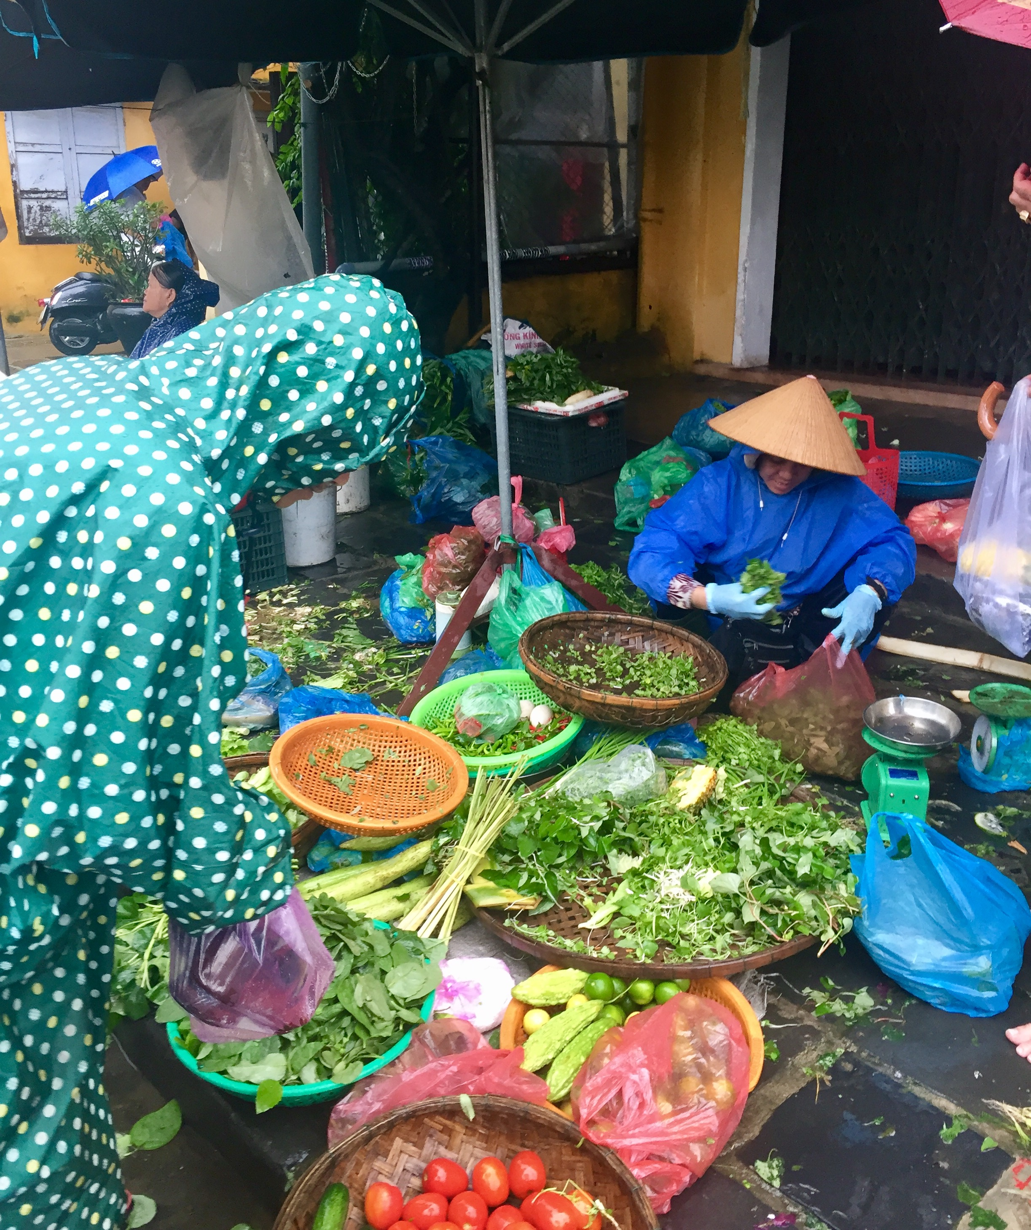

At the beginning of the conference, myself and seventy-five delegates met to discuss our economies and the issues that concerned us as young people in a globalised world. At the conclusion of the conference, myself and seventy-five new friends felt motivated to go back to our economies, inspired to inform others in our generation that our capacity to create change isn’t purely an idealistic vision for the future but a current opportunity.

As Noeleen Heyzer so rightly said in her Voices of the Future keynote address,

“We don’t have the capacity anymore to fix the planet later. We need to create and implement change now.”

I would like to express my sincere thanks to Duke of Edinburgh
Australia for granting me with this life-changing opportunity.
