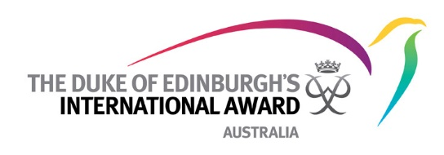

The Duke of Edinburgh’s International Award
FACT SHEET

The Duke of Edinburgh’s International Award is a leading youth development program that empowers all young people to explore their full potential, regardless of their location or circumstance. Every young person aged 14-25 who takes part learns a life skill, improves their physical wellbeing, volunteers in their community and experiences a team adventure in a new environment.

Through this challenging journey of self-discovery participants are equipped and empowered to achieve their personal best, to take ownership of their goals and life choices as well as become actively engaged within the community and workforce.

Run through schools, universities, indigenous communities, new refugee support programs, defence cadets, uniformed youth organisations, prisons, youth development centres and community organisations, The Duke of Edinburgh’s International Award participation is available in cities, rural and remote areas. Currently we have over 1,100 licensed award units who deliver the Award to nearly 40,000 youth with the help of over 80,000 volunteers across Australia.

With three progressively more challenging levels (Bronze, Silver and Gold) The Duke of Edinburgh’s International Award celebrates and recognises each Award as the improvement of an individual through persistence and achievement. Participants complete four sections - Service, Skill, Physical Recreation and Adventurous Journey through either extending their current activities or taking up completely new challenges.

With a rich global heritage, The Duke of Edinburgh’s International Award program was set up in 1956 by HRH Prince Philip, German educationalist Kurt Hahn and Lord Hunt, leader of the first successful ascent of the world’s tallest mountain, Mount Everest. The design of the Award is underpinned with strong, well tested educational and youth development principles.

Today more than 140 countries have adopted The Duke of Edinburgh’s International Award program and more than 8 million young people have participated worldwide. Locally over 700,000 young people have completed the Award in Australia in the past 57 years, with on average 40,000 very diverse participants annually working towards achieving an Award and in the process equipping young people for life and work.

Further information for participants, parents/guardians and volunteers is available at:
Website: www.dukeofed.com.au
Facebook: The Duke of Ed Australia
Twitter: Duke of Ed
Instagram: dukeofedaus
Telephone: 1300 4 DUKES (1300 438 537)

